Car Care One /Synchrony Instructions

If we are just processing a sale skip to step 9.

Using the Synchrony Preprinted forms, you must first have customer fill out and sign the application before you can proceed to online processing.

The customer may enter only the last four digits of his/her SSN, but they will have to enter the full SSN on-line on the application.
Ensure that the Customer Signs the application.

You need to keep page 1 of the application ensuring that it has been signed by the customer. All other pages of the application packet should be given to the customer. The signed application should be sent to the office in the next bill bag.
Step 1.
Go to www.mysynchrony.com and go to business center, select business center and then click go to business center then partner login and business center again.
Click Here

Step 2.
Enter your login information here. You received this on a separate sheet.
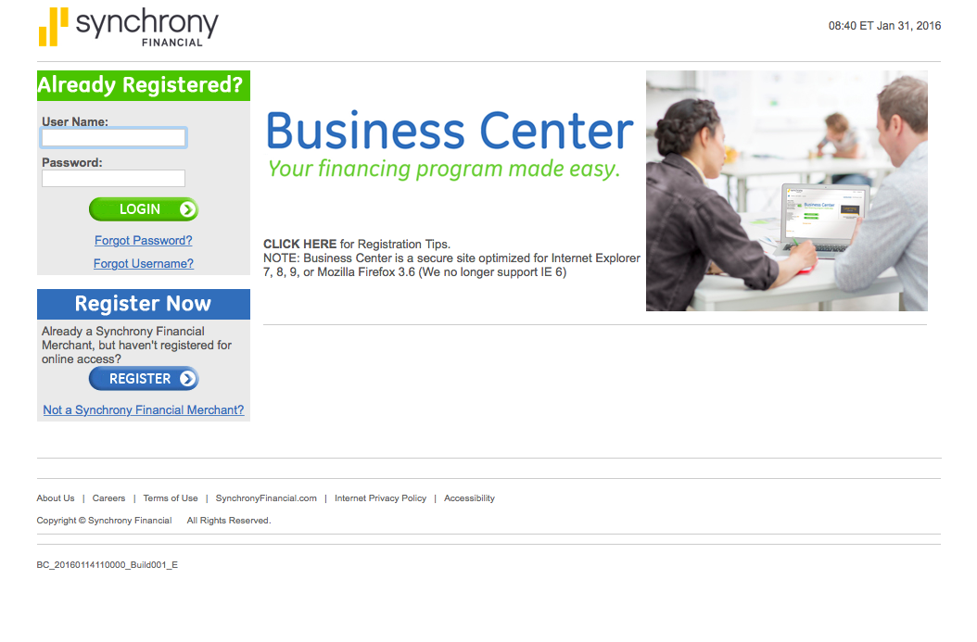

Step 3.
Answer your security questions to proceed to next screen. You should receive these in a separate email.

Step 4.
Select applications from this screen

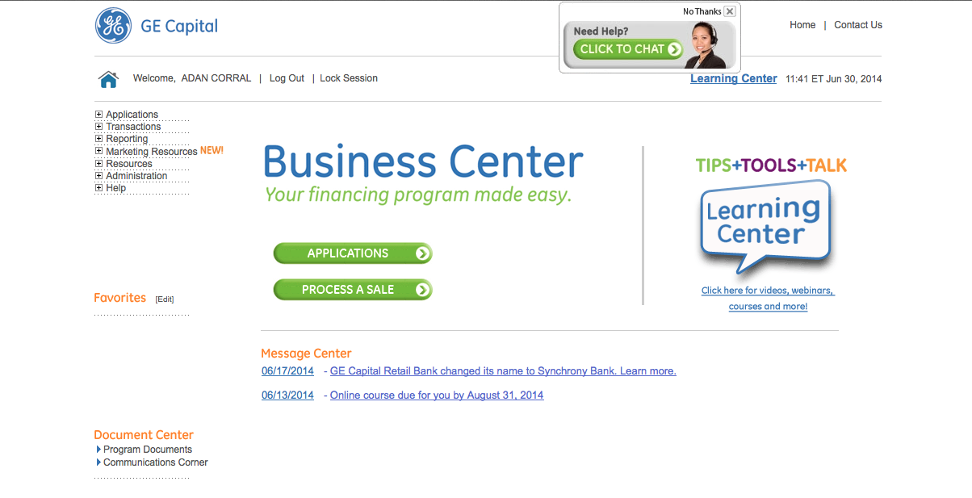

Step 5.
Select Car Care One from drop down menu and hit continue.
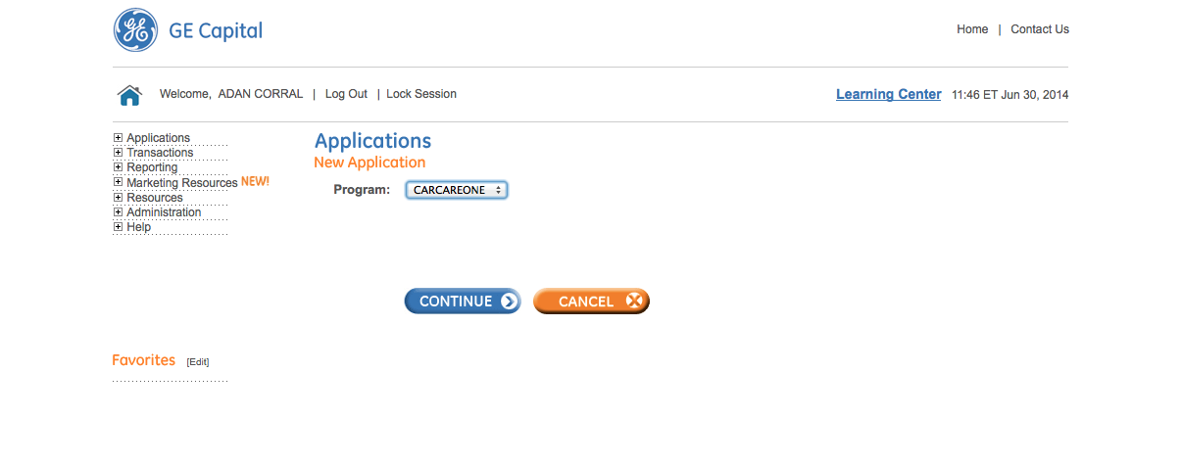
Step 6.
Enter in all the customer information from application here and hit continue.
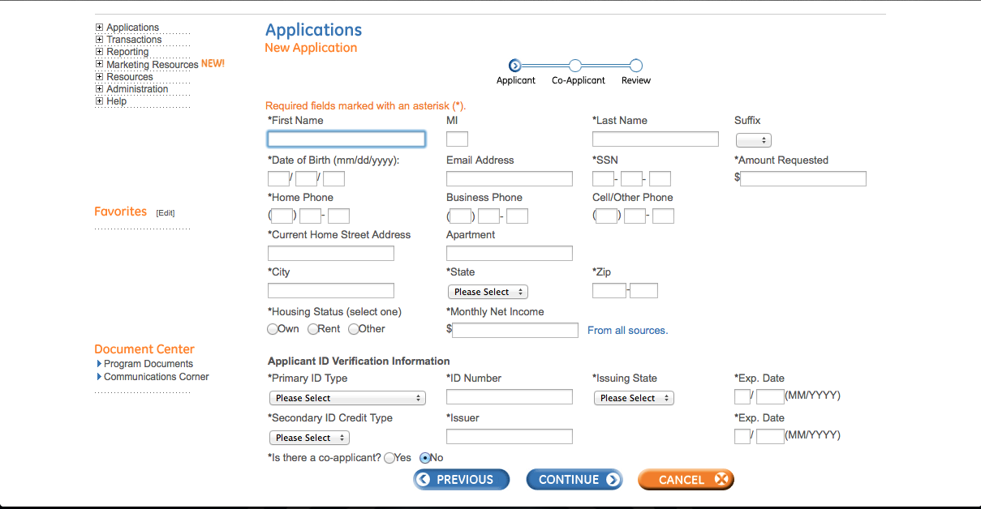
If the customer did not give you his/her whole SSN, they will need to type it in here. Only the last four digits will print

If there is a co-applicant, select yes.

Step 7.
Hit continue and proceed to either the co-applicant page or go to review customer information. Review application and hit submit.

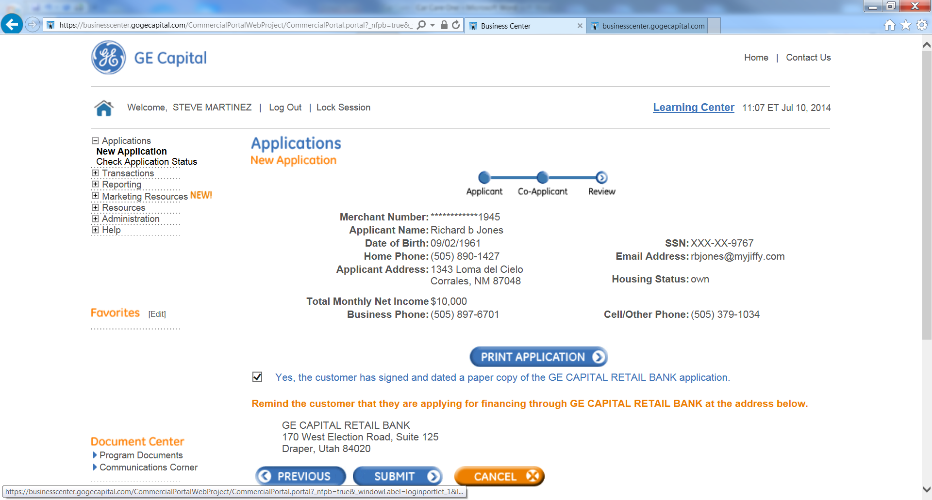

Step 8.
Process application: this is where the customer will either get denied or approved, if approved you will be given an account number that you will need to provide to the customer and also you will need to use the account number to process the sale.
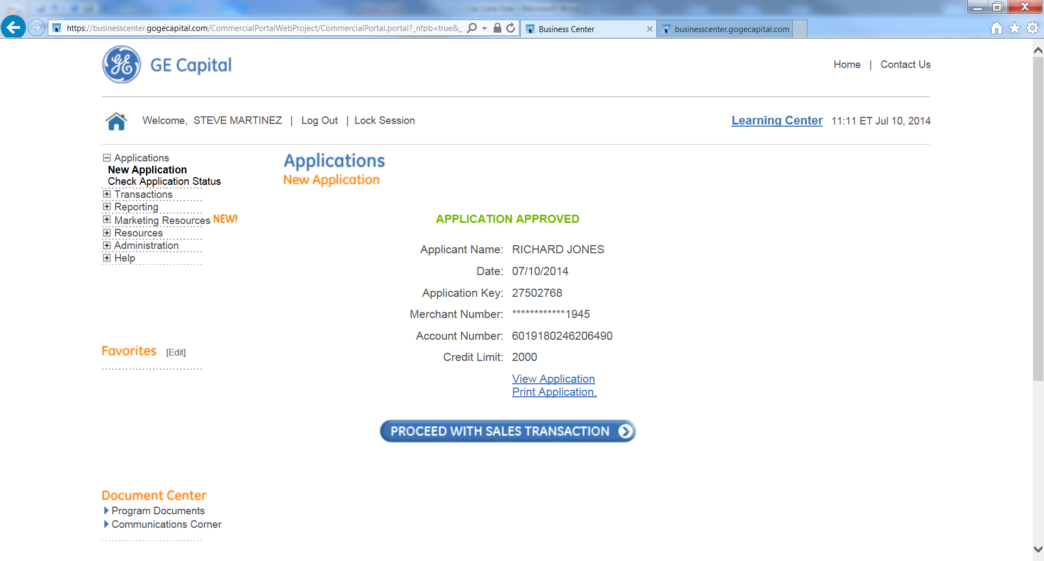

Print page one of the application. Select the print button and then select to print only page one. Use the account number on bottom of the page to process the sale in POS before you give the application printout to the customer.

Example of the One Page application that should be given to the customer.

Account number needed for processing the sale.

Step 9.
If approved you will need to process the sale through this screen, click application or go to menu on left and select transactions. This must be done prior to going to POS to ring out the customer, because you will need an approval number

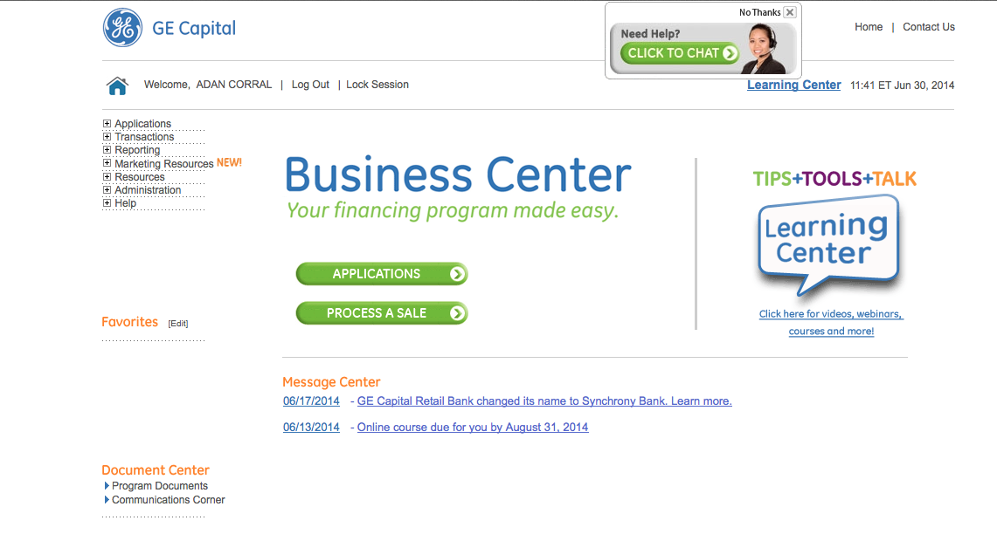
If the customer already has a card, you will need to select Transactions and process from there.

Step 10.
Select Car Care one and then select purchase from drop down menu enter account number (This is on the bottom of the application, or on the approval screen, or it could be on a card if the customer already has a Car Care One card. If new application, select Card Present No. If the card is present, select card present Yes. Once you enter the account number and answered the Card Present question, select Continue.
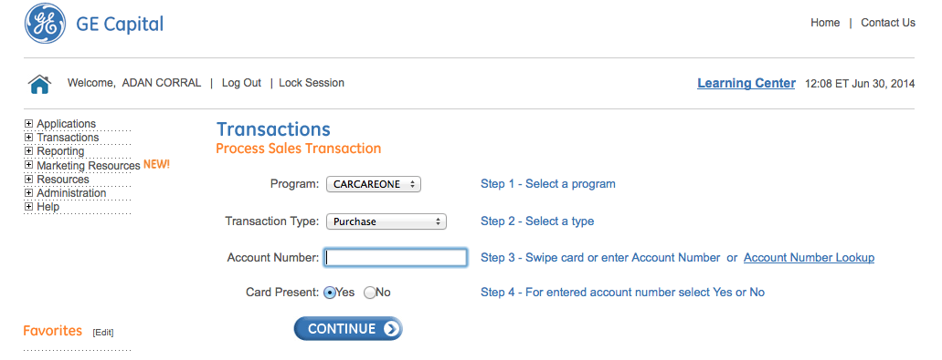
Step 11.
Enter Amount of the Invoice, Customer Name, and Tran/Promo code, which will always be 000 for 6 months same as cash and click submit, there is no need to enter the Invoice number.
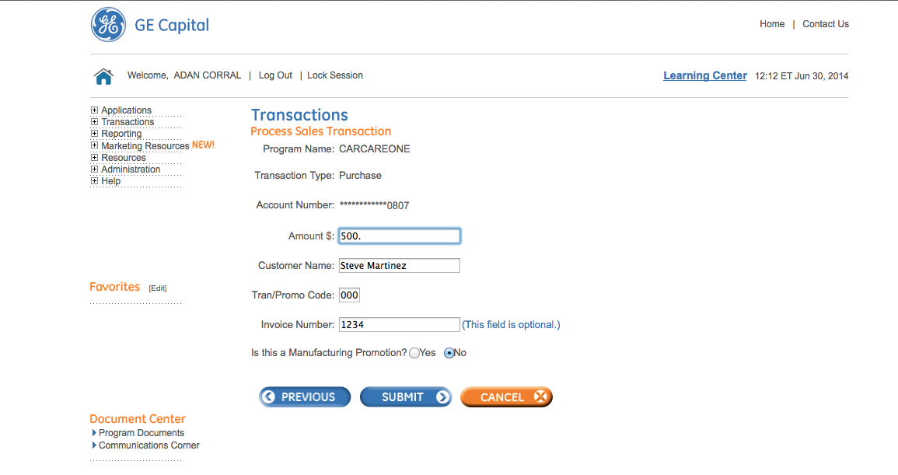
Click Submit and the following screen will appear.

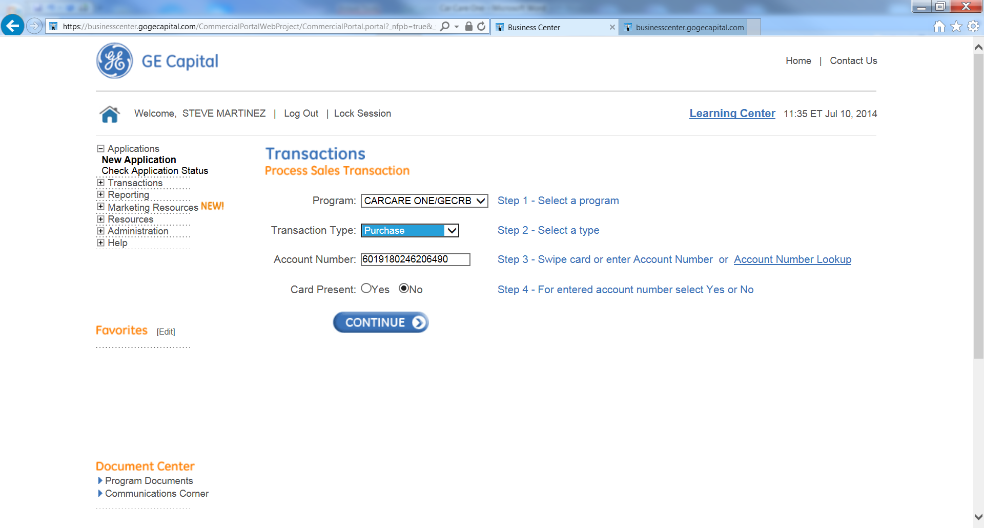
Select Transaction Type: Purchase, from the drop down menu.
Ensure that the Account Number is correct.
Select Continue

Step 12.
After card is processed you will get an authorization code, which you will need, to ring out the sale in POS system.

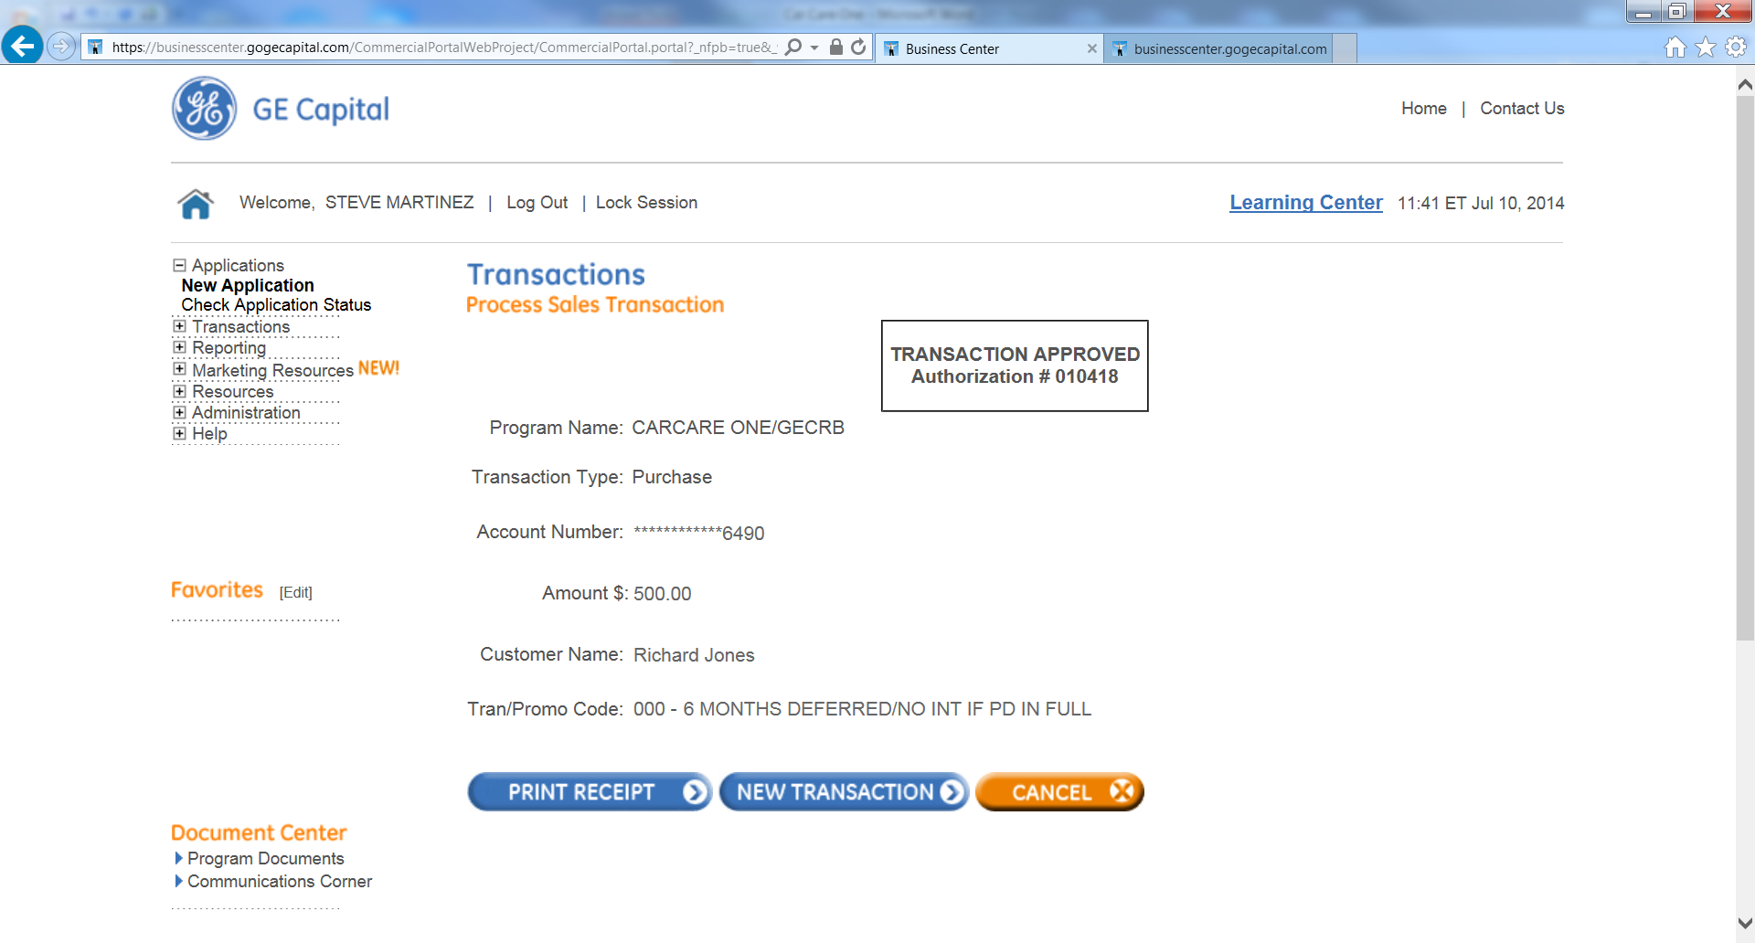
Select print receipt. You will print a customer copy and a Merchant Copy.
Attach the Customer Copy of the Receipt to the Customer’s Copy of the Invoice.
Have the Customer Sign the Merchant Copy of the Receipt and Attach to the store copy of the Invoice.

Step 13.
You will need to ring out the invoice in POS by selecting Car Care One from the MOP.
Enter the exact amount that was processed by Car Care One in the previous step and enter in the authorization number in appropriate line.

