This is the incentive flyer for the $25 gift card for every 5 customer we process a application for, remember we do not need to get them approved to receive the incentive we just need to process the application.

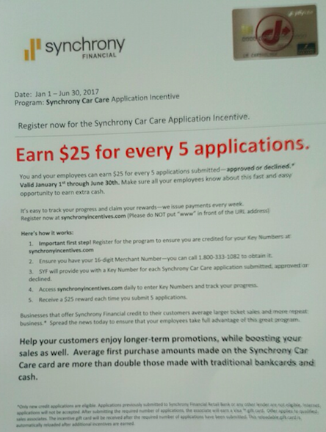

Step 1.

Go to https://www.synchronyincentives.com/Participant/Registration.aspx and follow instructions on how to register for incentive

Step 2.
Fill out the registration form with your information here:
Your manager will be able to get you the merchant ID from the Synchrony website or you can obtain it by logging into the business center.

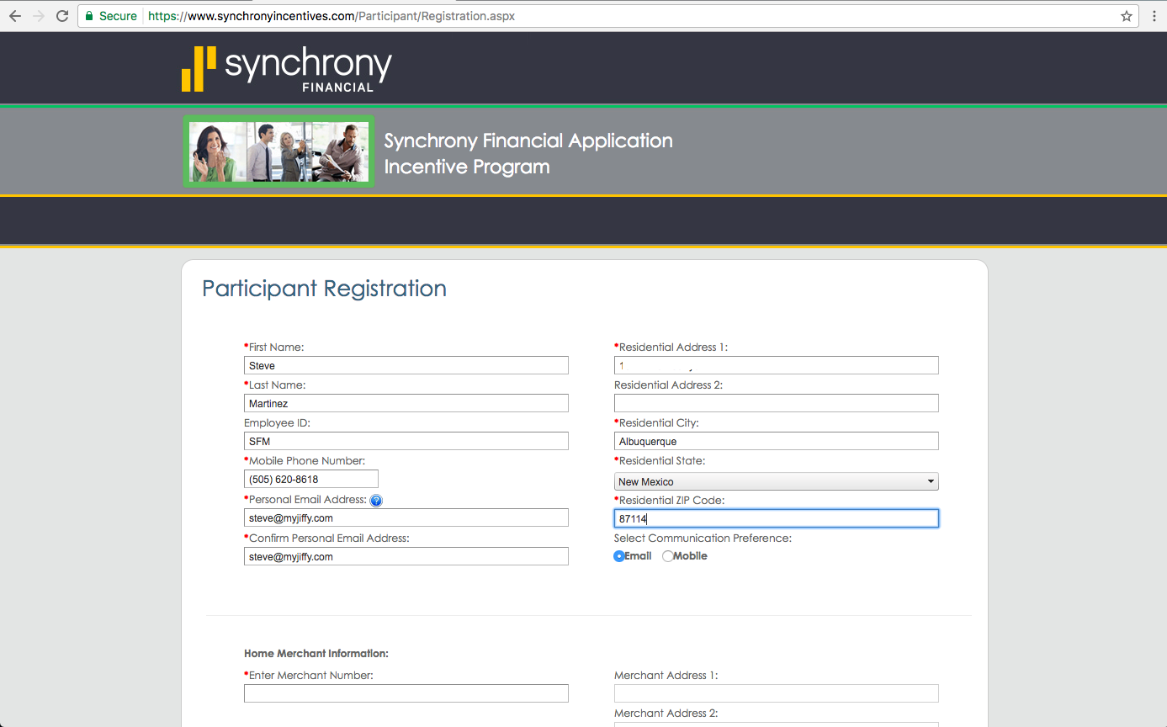

Step 3.
Create your username and password.

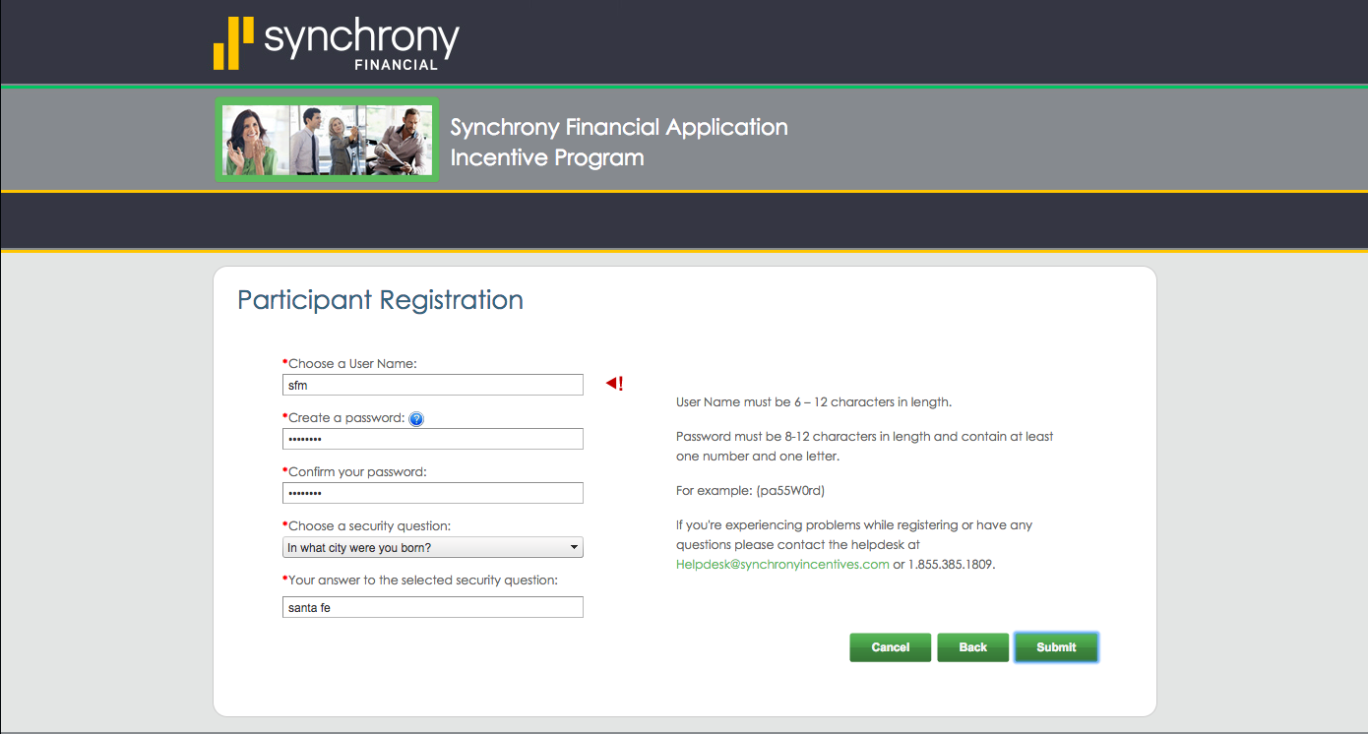

Step 4.

Your registration is complete, remember to follow instructions on screen below to make sure you get credit for each application. Remember if you have any questions please contact Steve Martinez at (505) 620-8618

