New Purchase Order Procedures

Log In to:
http://www.myjiffy.com/DBApps/podb/index.php
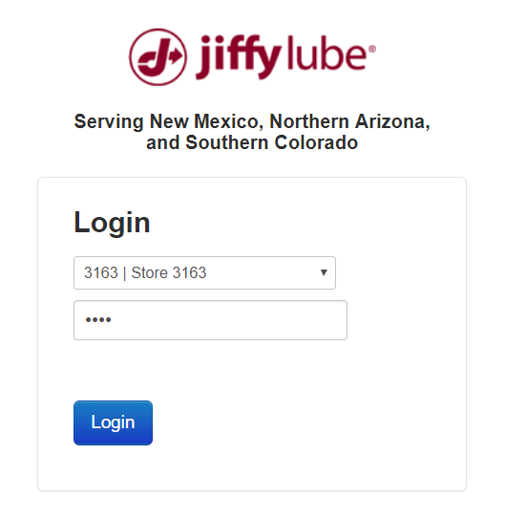
Login by Selecting your Store Number from the drop down box
Password is your store number.
This screen is a list of PO’s that you have entered to date.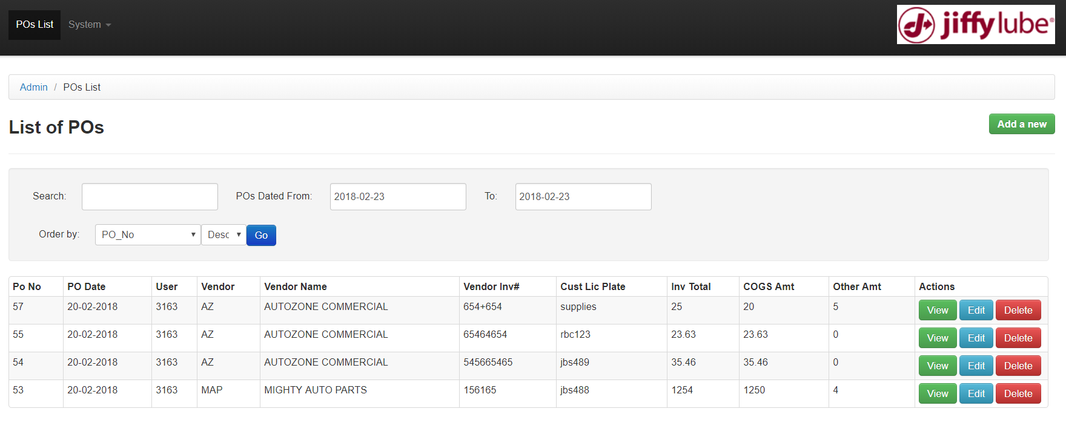
To add a new PO click on the green Add a New button
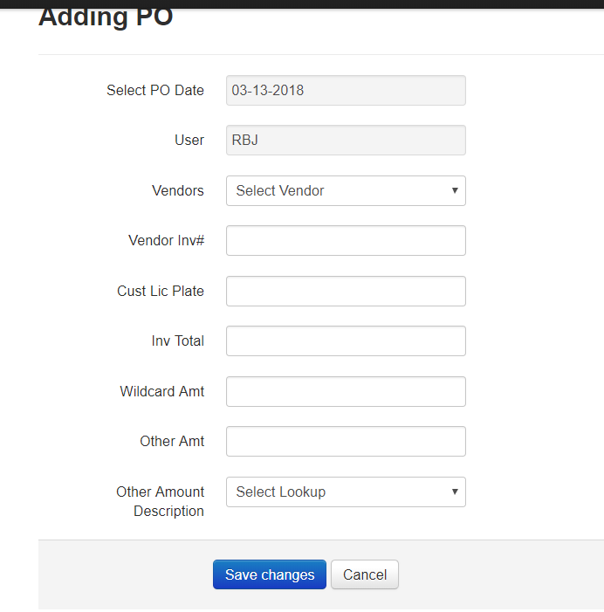
This screen contains similar fields as the old spreadsheet PO Log.
- Select a vendor from the drop down list. If you can’t find the vendor on the list, use Other.
- If you choose Other, the Other Vendor Name field will appear. Enter the name of the Other Vendor exactly as it is on the vendor invoice.
- Enter the Vendor invoice number. This must be typed exactly as it is on the vendor invoice, include the store identifier if part of the invoice number. Include dash (-). E.g. Mighty Invoice: IN008291. Parts Plus: 1-7156479
- Enter the Customer License Plate. If an item is purchased to go on a vehicle, and we don’t normally carry in inventory, you must enter the customer License Plate Number. Include the State: E.g. NM JBS488. If the item purchased is normally carried in inventory. Do not enter the Customer License plate, but you will need to Receive the item in inventory.
- Enter the Invoice Total, including tax, if any.
- Enter the amount of the invoice that is Wildcard. This is only for items that go on the Vehicle and are recorded on the customer invoice as a Wildcard, but are not normally carried in inventory. Enter zero if there are no Wildcard items on the invoice.
- Enter the Other amount. This is the total less any Wildcard amount. If there is tax on the invoice, it should be included in this cell. Enter zero if there isn’t any Other amount
- Select the Other Description from the drop down menu. Inventory, Office Supplies, Small Tools, Operating Supplies, Mishaps, or Maintenance. If there are multiple items select the one with the most items i.e. for Mighty select Inventory. A report will be available to show the allocation of the Might Invoice.
- Save Changes.
- Make any corrections that are identified with red error messages.
- Save Changes.
Credit Memos. In the event that you have a credit memo, please enter the memo in the PO log with a negative amount.
You can view, edit or delete a PO using the appropriate buttons.
Invoices from the following vendors do not need to be sent in to the office:
- Parts Plus
- O’Reilly Auto Parts
- Mighty Auto Parts
- Auto Zone
These vendors send their invoices via the internet.
For these invoices, you must receive the items as appropriate in GROW and attach the receiving report to the invoice. You will need to keep those invoices with the appropriate attachment (i.e receiving report) in a file for 60 days to help you resolve any questions that may come up.
Honstein delivers oil for Conoco Phillips, and also delivers their own product. Send in the delivery ticket and the Receiving Report for all items received from Honstein
Any invoice from a vendor not specifically mentioned above must be processed using the stamp. Use the PO number from the list of PO’s. The invoice must be sent in to the office in the very next bill bag.
You do not need to printout the PO List or send it in.
The back office will have complete access to the items that you type.
Invoices received via the internet and will be matched against the PO list typed from the store. On a weekly basis, Accounts Payable will send out an unmatched report that you will need to chase down. So it is critical that the Vendor invoice number and Customer License Plate are accurately entered.

