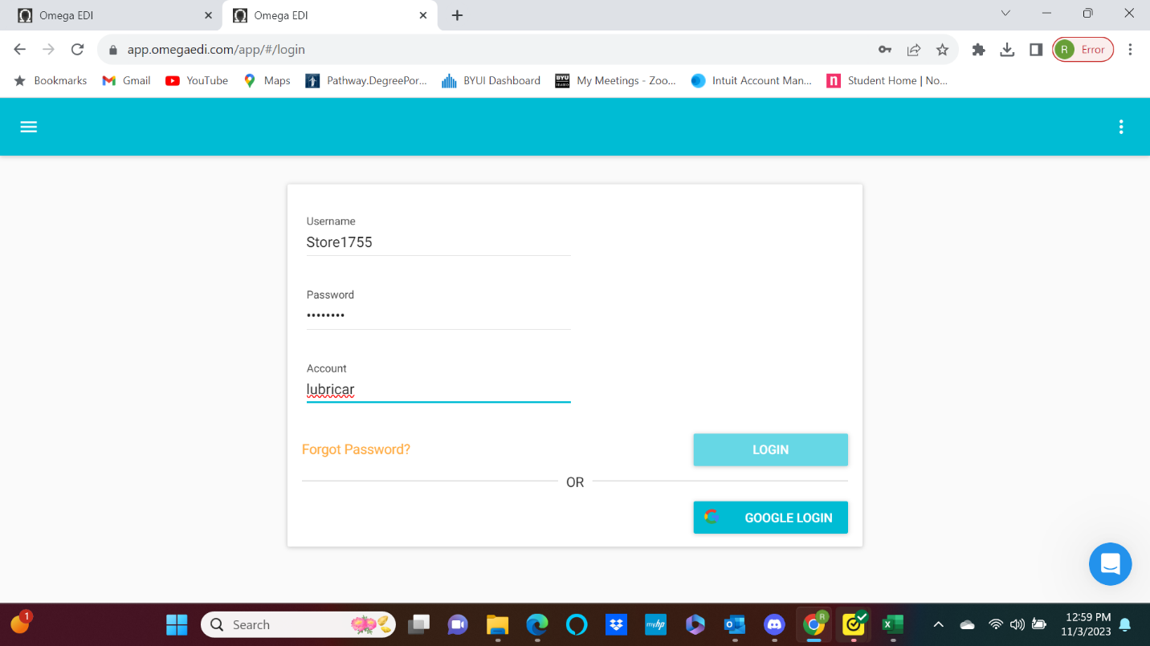
jiffy123
Use the URL app.omegaedi.com this will take you to the login page.
The login is Store#### (your store number). You can see in the screenshot above for Store 1755 their user name is Store1755.
The password for every location is the same. It is jiffy123 No capital letter in jiffy.
The account as you can see in the screenshot above is lubricar This is the same for every location as well.
Once you have typed in your user name, password AND account, click the login button.

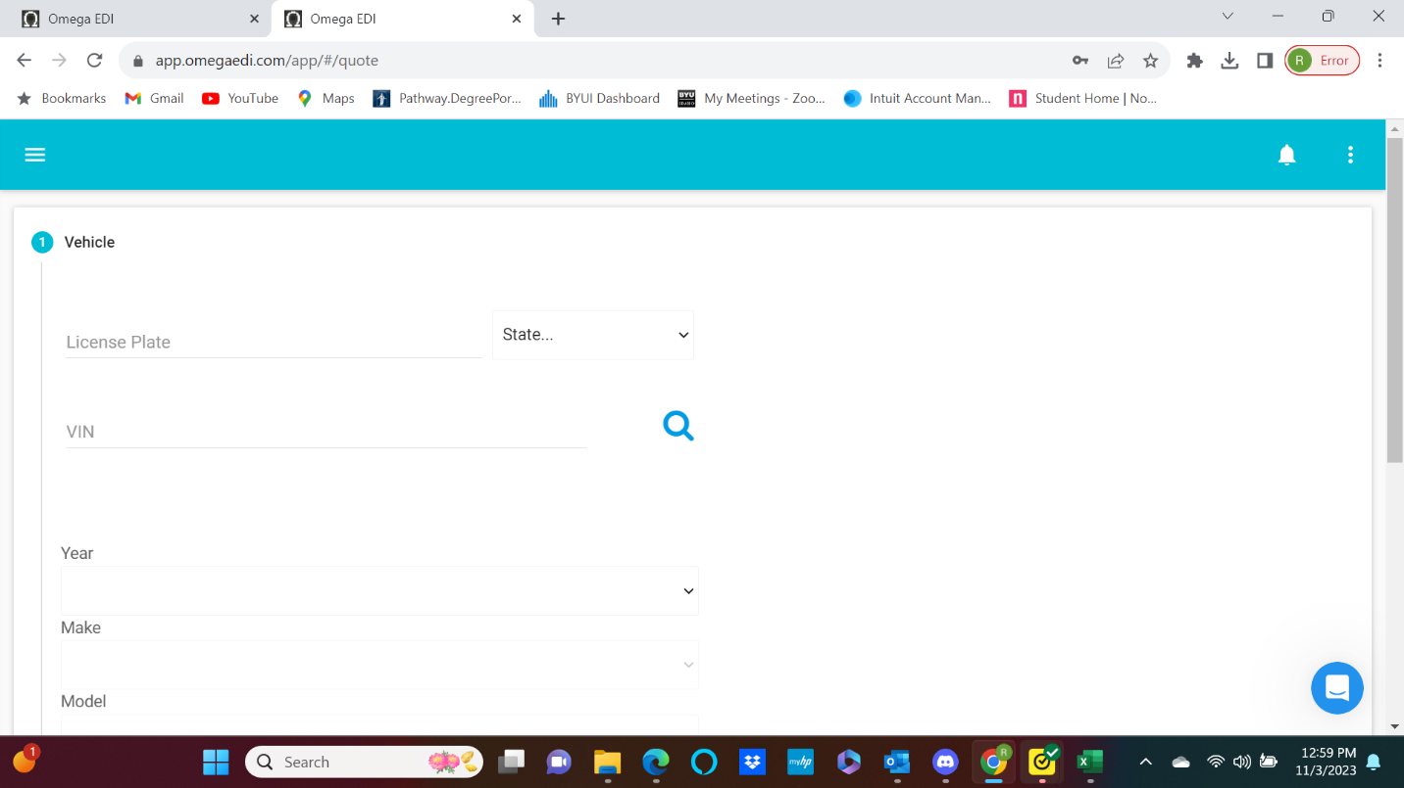

When you click the login button you will land on this page.
In the upper left-hand corner, click the 3 lines.

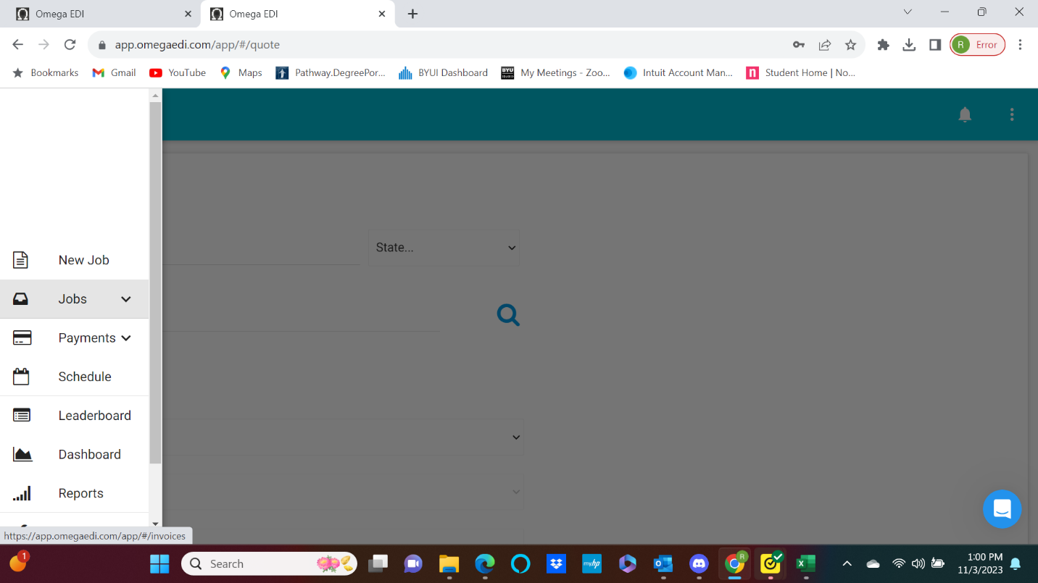
When you click on the 3 lines, it will open this menu for you.
Simply select the “Jobs” option

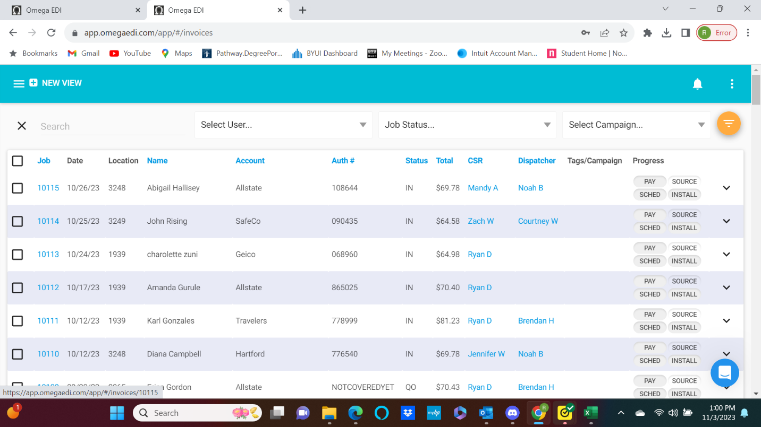
Once you click the “Jobs” option, it will option the job page for you. Find the job the call center built for you and click on the blue job number.

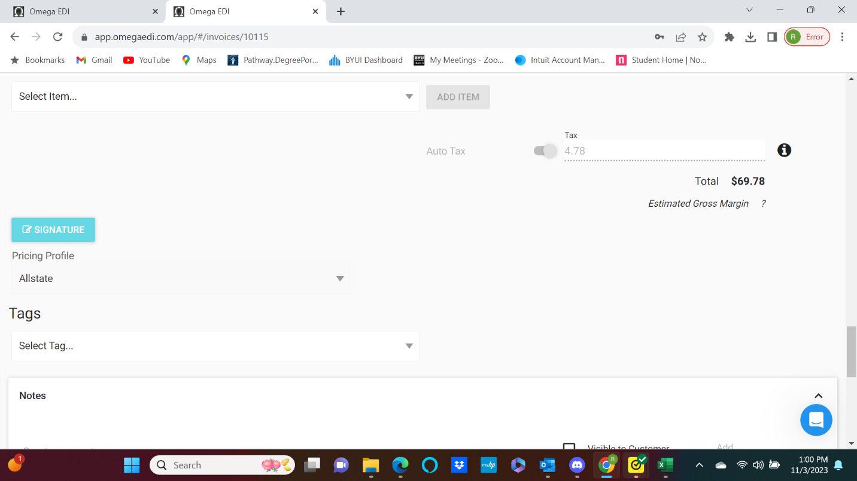
Scroll down until you see the “Signature” option…
Click the “Signature” button
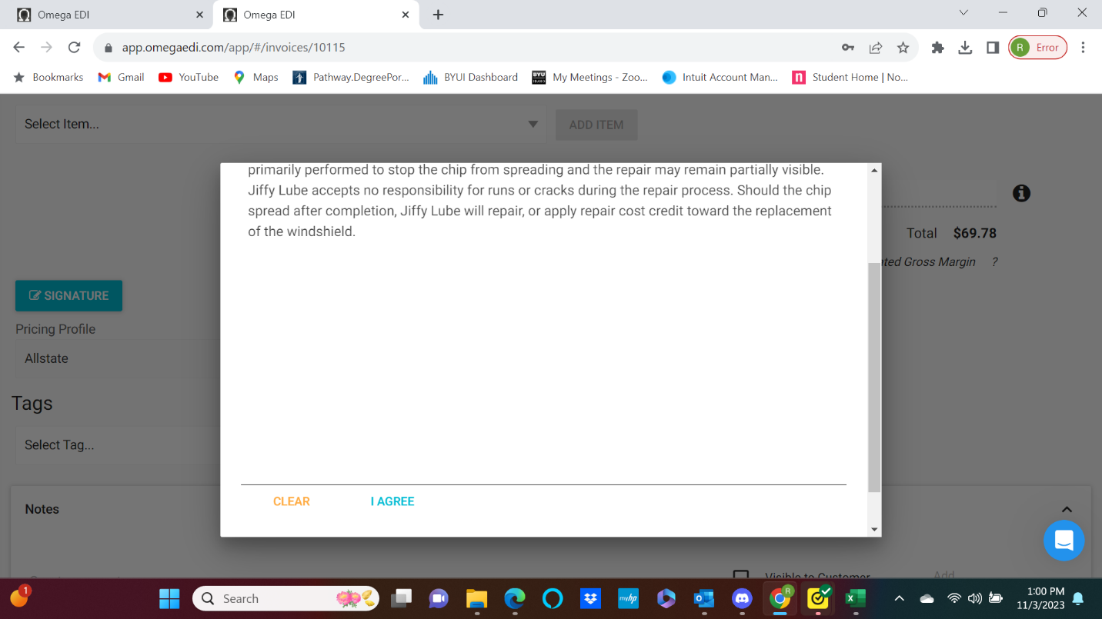
This screen will appear. Have the customer use the computer mouse to sign their name, then click “I Agree”
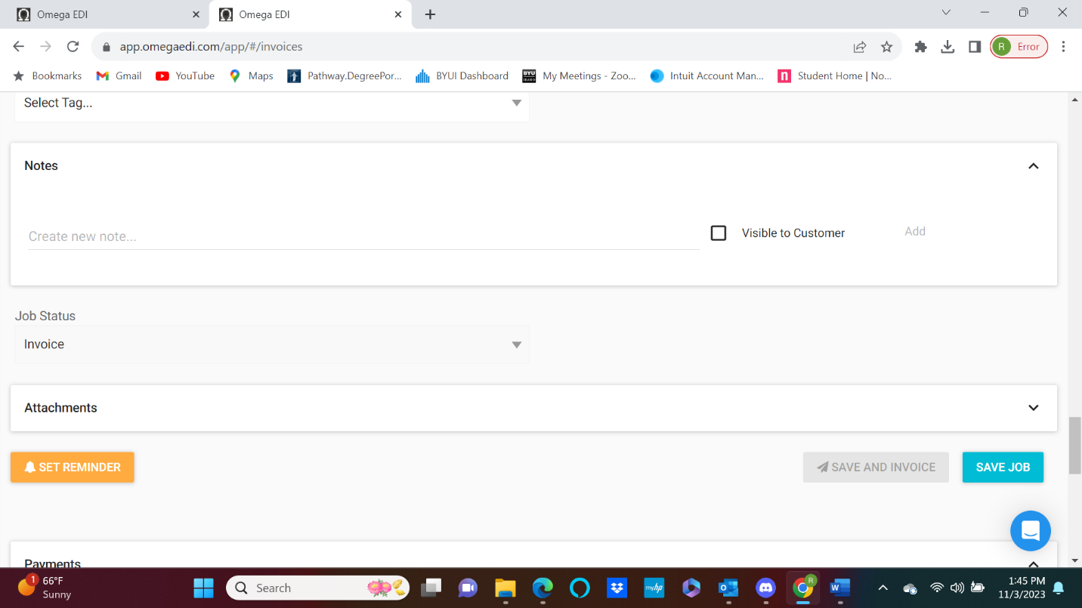
Once the customer has signed the invoice, the signature screen will go away and you will be taken back to the job page. At this point, scroll down until you see “Save Job” tab. Click “Save Job” and the invoice is complete.

