NTB-800 Manual

Please read this Manual before using the Machine. You will need to know the safety instructions, System Settings, Wheel Parameters Input and Calibration process before you can properly balance a wheel.

Contents

- Safety Instructions
- Product Description
- Product Installation
- Control Panel
- System Settings
- Wheel Parameters Input
- Calibration
- Standard Dynamic Mode
- Static Mode
- ALU1-3 Mode
- ALUS Mode
- OPT Mode
- Motorcycle mode
- Errors and Trouble Shooting

1. Safety Instructions

- All operators should be properly trained. Improper operations may result in incorrect measurement.
- All operators should not wear loose clothing or jewelry. These things may become entangled with the wheel or spin shaft while using the balancer and could cause serious injury.
- All operators should were protective eye wear.
- Safety guard should be used to avoid injury.
- The wheel balancer contains electronics and should be kept indoors and in a dry environment. Exposure to water can cause damage and is not covered under any warranty.
- Exposure to extreme heat can damage internal parts of the wheel balancer.
- The wheel balancer does not have an electrical surge protector. The user should supply a surge protector to avoid damage to the wheel balancer in the event of an electrical surge or storm.
- Do not use the wheel balancer beyond its measurement or weight range. Using the wheel balancer beyond its measurement or weight range could cause damage to the wheel balancer and does not ensure a precise balance of the wheel.
- Other safety regulations may be in place according to OSHA or your local city and county. These should all be followed in addition to the instructions in this manual.

2. Product Specifications

Please see www.nationalautotools.com for the specifications on your wheel balancer.

3. Product Installation

- Remove Wheel Balancer from shipping crate and pallet.
- Place Wheel Balancer on flat and stable floor.
- Install the Safety hood.
- Install threaded rod to spin rod extruding from side of the machine using the hex bolt.
- If Wheel Balancer shakes or moves while spinning the wheel, it needs to be bolted to the ground to ensure proper function.
- Electrical plug is preinstalled to fit North American 110 volt electrical socket. Plug into proper electrical socket. Do not hard wire directly to your electrical source. There is no power surge protection on the machine. Please use a power surge protector to ensure your machine is not damaged.
- Install the wheel balancer in a dry and safe environment. Exposure to moisture or extreme heat can damage the components inside the wheel balancer.

4. Control Panel

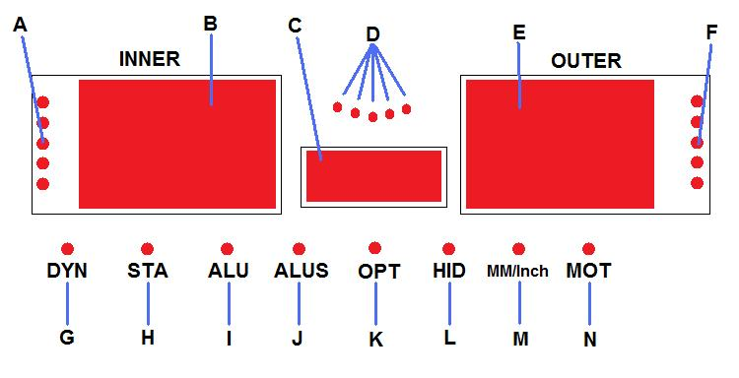

- Inside Unbalance Point
- Inside Unbalance Display Window
- Middle Static Unbalance Display Window
- Sticking and Clamping Weight Position Indicator
- Outside Unbalance Display Window
- Outside Unbalance Point
- Standard Dynamic Mode
- Static Mode
- ALU Mode
- ALUS Mode
- OPT Mode
- Split/Hidden weight indicator
- Mm/Inch Indicator
- Motorcycle Mode

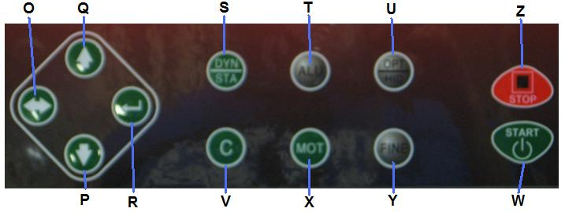

- Wheel Parameters Input and Shift Key
- Down Key
- Up Key
- Enter Key
- Dynamic/Static Mode Key
- ALU Mode Key
- OPT/HID Key
- Measurement Unit Key
- Start Key
- Motorcycle Mode Key
- Fine Measurement Key
- Stop Key

This is the beginning screen that will be displayed when you first turn on the machine:

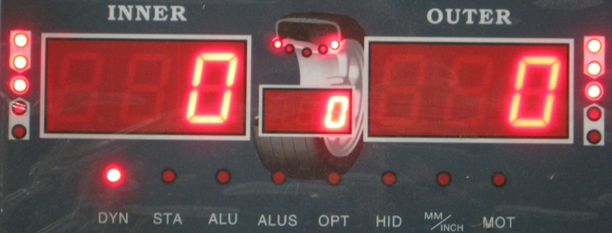
If set to Grams.

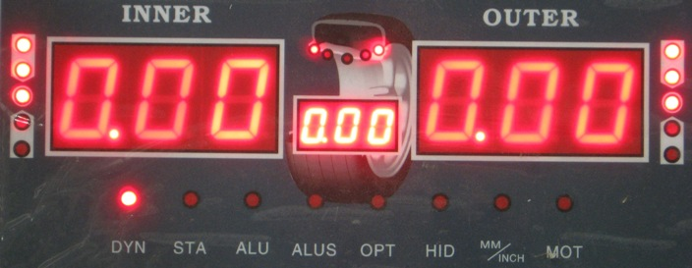
If set to Ounces.

At anytime you may change from Ounces to Grams and back by simply pressing the C button.

5. System Settings

This section shows the user how to change the various system settings to meet their needs. You will need to check the settings and adjust them accordingly before balancing a wheel.

Step 1: Hold down the “ENTER” button until you see:

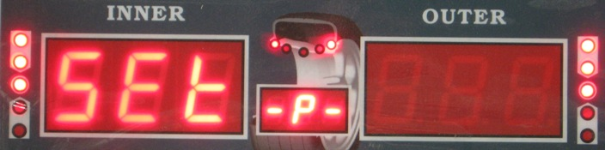

You are now in the system settings mode.

Use the UP and DOWN keys to navigate the different setting selections. You will see that the display in the MIDDLE STATIC UNBALANCE DISPLAY WINDOW: 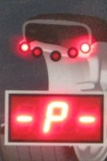 will change as each time you press the UP or DOWN keys.

Here are the descriptions for each system setting that can be changed:

Guard control setting: If set to “On” the machine will not allow a wheel to spin while the safety hood is in the up position. If set to “Off” the machine will ignore the safety hood and will spin when the user presses START.

Standardization display setting: Set to 1g or 5g if using grams to measure. Set to .10 Oz or .25 Oz if you are using Ounces to measure. This sets the multiple in which the weight will be displayed on the display board.

Least unbalance value setting. Set between 1 g-40 g or .1 Oz-1.5 Oz. When the machine spins the wheel, any unbalance amount less than your setting will display as 0.

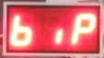 Buzzer switch setting. Change to “On” or “Off” to control the buzzer sound.

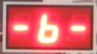 Width Input setting. Change width input to Grams or Ounces. Grams will display “0.” and Ounces will display “0.0”.

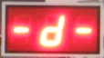 Diameter input setting. Change Diameter input to Grams or Ounces. Grams will display “0.” and Ounces will display “0.0”.

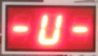 Unbalance unit of measurement. “Gr” means the unit will display in grams. “OS” means the unit will display in ounces.

Once you have found the system setting that you wish to change, press the ENTER key. This will then allow you to change the system setting to fit your needs. For example, the display will change to:

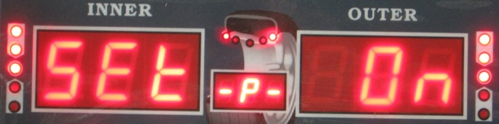

To Change this setting to off, push the UP or DOWN arrow. Once you have the setting correct to fit your needs, press the ENTER button to return to the system settings main menu. You can now use the UP or DOWN arrows to move to the next setting you wish to change.

Once you have made all the system setting changes you need, press the WHEEL PARAMETERS INPUT AND SHIFT KEY which looks like: 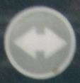 . This will save your changes and return you to the original balancing screen. To exit the system settings without saving your changes, press the STOP key.

If the above system settings instructions are not understandable, refer to following diagram:

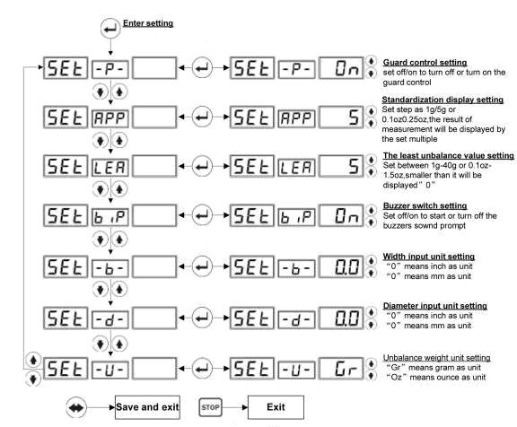

6. Wheel Parameters Input

Install the wheel in either of the two ways shown here:
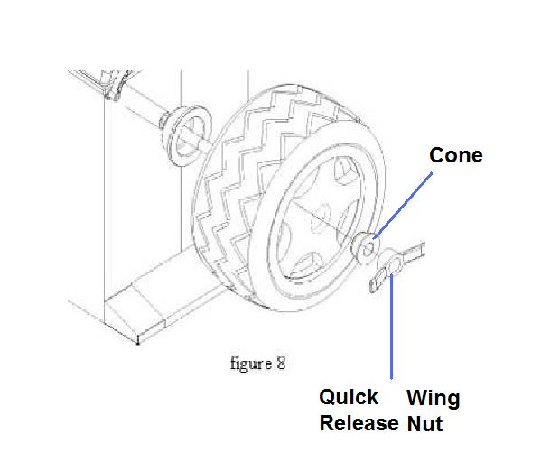

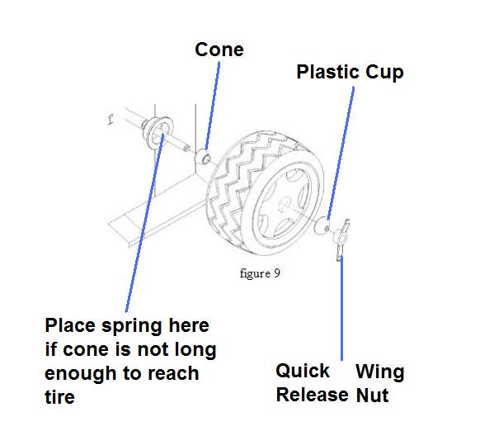

This must be performed before calibration and before balancing any wheel. If all four wheels for one vehicle are the same and being balanced, then parameters only need to be input one time. If you turn off the machine, the wheel parameters are forgotten and must be entered again.

To enter the wheel parameters input menu, press the WHEEL PARAMETERS INPUT AND SHIFT KEY .

The display screen will show the following:
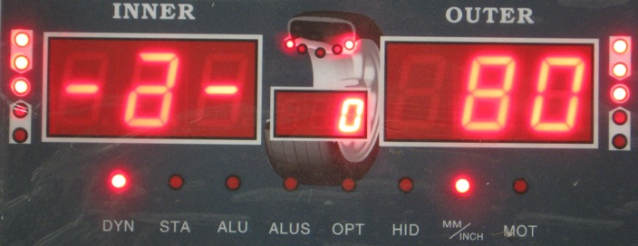

The number in the OUTSIDE UNBALANCE DISPLAY WINDOW may be different if you have used the machine before.

There are 3 parameters that must be entered when using Dynamic, Static, ALU1-3 and motorcycle mode.
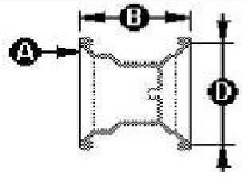

With the Model NTB-800 you must only enter one parameter manual and the other two will be entered automatically using the ruler.

Simply pull the ruler from the side of the machine and touch the end to the under lip of the rim. Parameter A and D will automatically show up on the screen and will be saved.

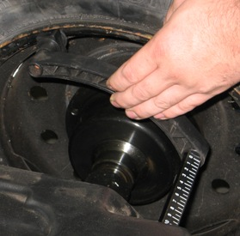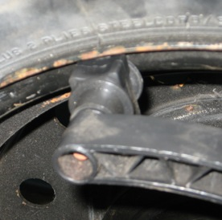

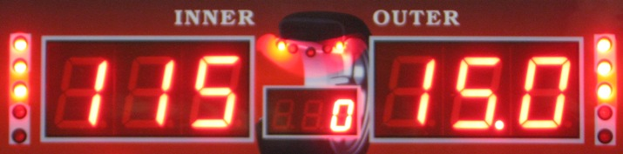

The screen will then change to parameter B which you must use the caliper to measure and enter the correct size. Use the UP or DOWN keys to change the number. When you are finished entering each of the 3 parameters, simply push the STOP button to return to the balancing screen or if you already have your mode selected, you may close the hood and spin the wheel to begin balancing process.

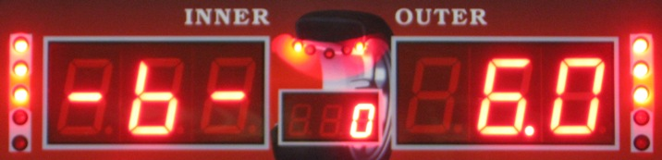

If you wish to enter the parameters manually, please use the following rules:

You use the WHEEL PARAMETERS INPUT AND SHIFT KEY to navigate to each parameter screen. You will use the UP or DOWN key to change the measurement for each parameter. When you are finished entering each of the 3 parameters, simply push the STOP button to return to the balancing screen or if you already have your mode selected, you may close the hood and spin the wheel to begin balancing process.

The first parameter will look like this:
This parameter measures the distance of the wheel from the balancer. This is the A parameter. Use the built in ruler and extend it to the edge of the rim. You then multiply the measurement by 10 and enter than number for this parameter using the UP or DOWN key. For example if the ruler shows 8, you multiply this by 10 to get 80. Enter 80 as shown in the picture above. After you have this parameter entered, push the WHEEL PARAMETERS INPUT AND SHIFT KEY to navigate to the next parameter.

The second parameter will look like this:
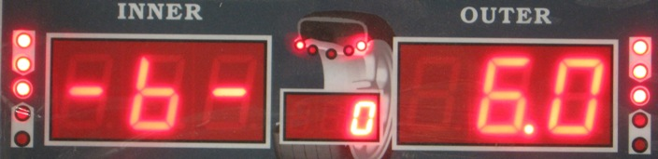
This parameter measures the width of the rim. This is the B parameter. Use the plastic caliper provided with the machine to measure the width of the rim. Touch the caliper to the edge of the rim on both sides to measure the width. Use the UP or DOWN key to enter the parameter. Do not multiply this number like you did with parameter A. Simply enter the number as shown on the caliper. After you have this parameter entered, push the WHEEL PARAMETERS INPUT AND SHIFT KEY to navigate to the next parameter.

The third parameter will look like this:
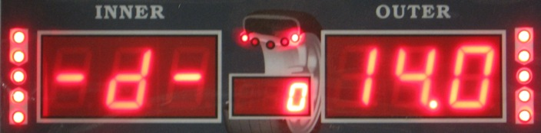
This parameter measures the rim size. This is the D parameter. Use the plastic caliper provided with the machine to measure the width of the rim. Touch the caliper to the edge of the rim on one side to measure the rim size. Use the UP or DOWN key to enter the parameter. Do not multiply this number like you did with parameter A. Simply enter the number as shown on the caliper.

When you are finished entering each of the 3 parameters, simply push the STOP button to return to the balancing screen.

At any time you may press the C button to change from Ounces to Grams. You can only do this when entering the B and D parameter.

When using ALUS mode, you must enter 4 parameters as shown in this diagram:
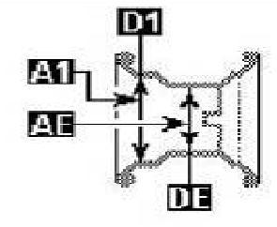

This must be performed before calibration and before balancing any wheel. If all four wheels for one vehicle are the same and being balanced, then parameters only need to be input one time. If you turn off the machine, the wheel parameters are forgotten and must be entered again.

7. Calibration

Calibration must be performed before machine will balance a wheel. If you move your balancer, calibration must be performed again. If you unplug or lose power to your balancer, calibration must be performed again. You do not have to leave the balancer power on, but do not unplug it from the electricity. Please remember to use a power surge protector to prevent damage to the electronics.

To begin, you must have a 15 or 14 inch steel rim with tire. If you don’t use a 15 or 14 inch steel rim, the machine will not balance correctly. Install this on the machine.

First, enter the wheel parameters then return to the initial balancing screen.

To enter the calibration process, do the following:

Push and hold down the FINE button. While holding down the FINE button, push and hold down the ENTER button. With both buttons being pushed, release the FINE button. The following screen should appear:
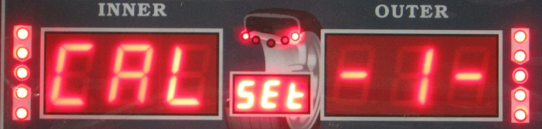

Now push and hold the ENTER button. While pushing and holding the ENTER button, push and hold the FINE button. The following screen will appear:
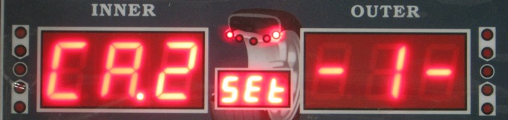

Now press and release the ENTER button one time. The following screen will appear:
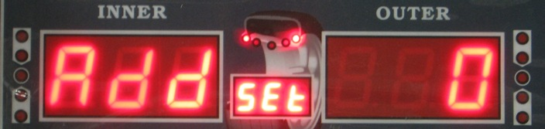

Now close the plastic hood and spin the wheel. If you have the guard control setting to “On” then the wheel will spin when the hood is closed. If you have the guard control setting is set to “Off” then you must push the START button to spin the wheel.

Let the wheel spin and come to a complete stop before opening the plastic hood. The screen will then show the following:
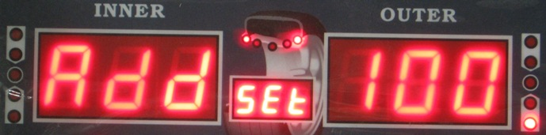

Use your hand to rotate the tire until all 5 of the lights in the OUTSIDE UNBALANCE POINT are on, as shown here:
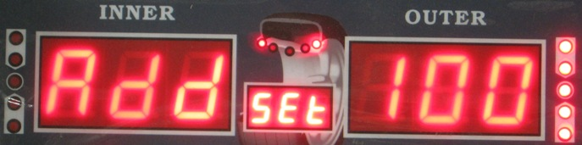

Then place the 100gram or 3.5 Ounce weight that came with the machine at 12 0’clock on the outside of the rim using the provided wheel hammer. 100 grams = 3.5 ounces so either weight is ok. Remember that at anytime you can switch from Grams to Ounces and back by just pushing the C button.

After placing the weight, close the hood and spin the wheel. The following screen will appear:
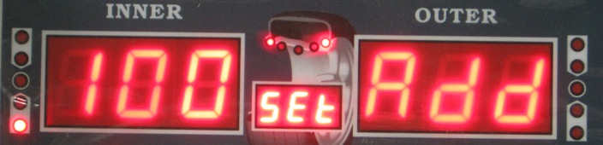

Remove the weight from the outside of the rim. Use your hand to rotate the tire until all 5 of the lights in the INSIDE UNBALANCE POINT are on, as shown here:
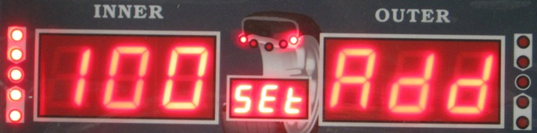

Then place the 100gram or 3.5 Ounce weight that came with the machine at 12 0’clock on the inside of the rim using the provided wheel hammer. 100 grams = 3.5 ounces so either weight is ok. Remember that at anytime you can switch from Grams to Ounces and back by just pushing the C button.

After placing the weight, close the hood and spin the wheel. The machine will beep and you will see the following screen for a short time:
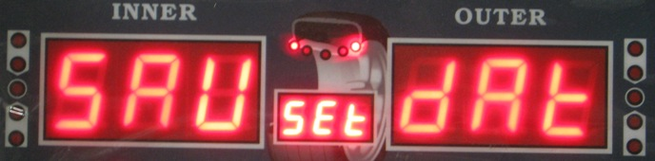

After showing this screen, the machine will automatically return to the initial balancing screen. You have successfully calibrated the machine and the data was saved automatically.

Please note that if you do not put a wheel weight on the rim, the machine will not calibrate. You will cause the machine to “chase itself to infinity” when trying to calculate the calibration. The resulting screen will look like this:
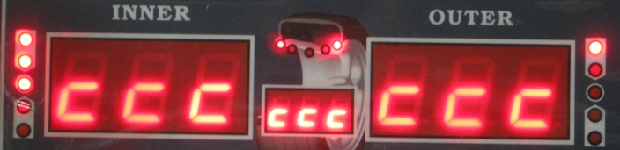
If you see this screen, you did not calibrate it correctly. Turn off the machine and try again.

8. Standard Dynamic Mode

After completing the steps above, you are now ready to balance. Standard Dynamic mode is for balancing steel wheels by placing clip on weights on both the inside and outside of the rim. It is not for using aluminum wheels or stick on weights.

This is an example of balancing a steel wheel:

Start by placing the wheel on the machine and entering the parameters. Close the hood and spin the wheel. You will see:
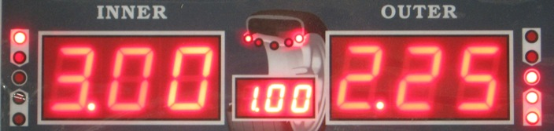

Use your hand to rotate the tire until all 5 of the lights in the OUTSIDE UNBALANCE POINT are on, as shown here:
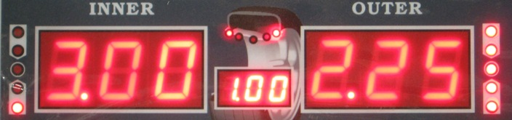

Then place the 2.25 Ounce weight that came with the machine at 12 0’clock on the outside of the rim using the provided wheel hammer. After placing the weight, close the hood and spin the wheel. The following screen will appear:
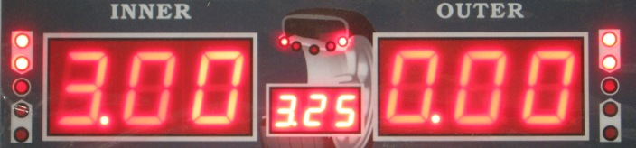

You have now zeroed out the balance for the outside of the rim.

Use your hand to rotate the tire until all 5 of the lights in the INSIDE UNBALANCE POINT are on, as shown here:
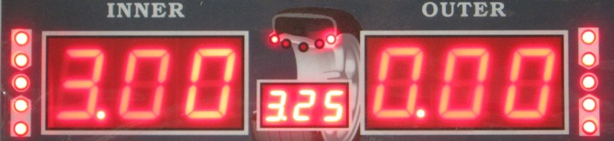

Now place the 3.00 Ounce weight that came with the machine at 12 0’clock on the outside of the rim using the provided wheel hammer. After placing the weight, close the hood and spin the wheel. The following screen will appear:
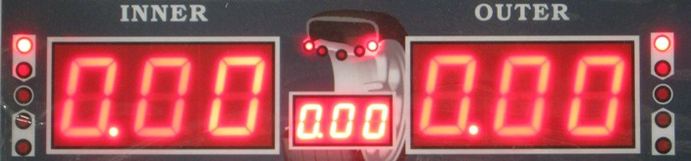

You zeroed out both sides and successfully balanced the wheel.

Please note that the machine is showing the wheel is balanced within the parameters you set in the system settings, specifically the “least unbalance value setting”. In the above balancing example, my “least unbalance value setting” was set to .70 ounces. After spinning the wheel and placing the weight, any unbalance value remaining that was less than .70 ounces was ignored and instead the machine showed it zeroed out.

This is where the FINE button comes into function. At anytime while balancing, you can press the FINE button to show the exact unbalance value. The most accurate values are 1 gram or .10 Ounce using the FINE button. Please see the following screen. This is the remaining unbalance value after the balancing example shown above was performed.
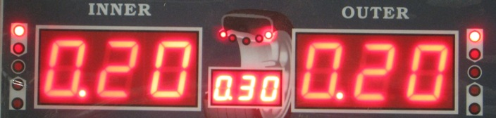

As you can see, the wheel is still technically out of balance by .20 Ounces on both sides. However, because I had the “least unbalance value setting” on .70 Ounces, the machine ignored the remaining .20 ounces because it was less than .70 ounces.

.20 Ounces may or may not make a significant difference depending on the size of the wheel and rim.

The FINE button function can be used in any of the balancing modes.

9. Static Mode

Press the DYNAMIC/STATIC MODE KEY to switch between Static and Dynamic mode. In static mode, everything functions the same as in Dynamic mode. However in Static mode you are only balancing the wheel by placing weight on the outside of the rim instead of on both sides.

10. ALU1-3 modes

This mode is used for Rims that do not accept clip on weights on one side or both sides. All parameters will be entered the same as in Dynamic mode. Please refer to the STICKING AND CLAMPING WEIGHT POSITION INDICATOR on the display screen as wheel as the following diagram to show where to place the weights on the rim.
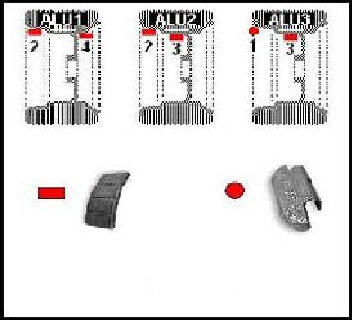

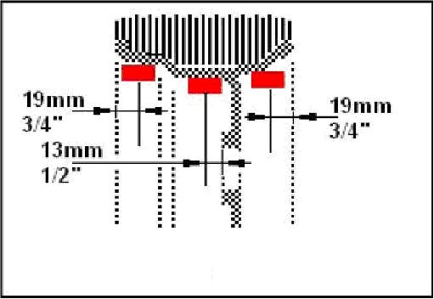

11. ALUS mode

ALUS requires the user to enter 4 parameters as mentioned in the parameter entry instructions. As a result, ALUS will be the most accurate mode when using stick on weights. Please refer to the STICKING AND CLAMPING WEIGHT POSITION INDICATOR on the display screen and the following diagram when placing the weights on the rim.
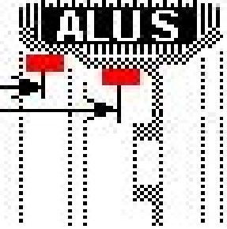

The process is the same as the dynamic and static modes. The only difference is the parameter input and the position where weights will be put.

12. OPT mode

Please refer to the tire manufacture for instructions on how to match tires to the correct rim.

13. Motorcycle mode

Motorcycle mode requires a special motorcycle adapter to mount the wheel to the machine. This adapter can be purchased separately as is it is not included with the wheel balancer.

To balance a motorcycle wheel, enter the 3 parameters and complete the balance process just like in dynamic mode.

14. Errors and Trouble shooting

Error | Meaning | Solution
ccc ccc | The result of measurement is beyond the range. | The user did one of the following: the user attempted to calibrate the machine but did not add wheel weights. The user placed a wheel that is either too light or too heavy for the machine.
OFF OFF | Machine gives this prompt when the STOP button is pressed while a wheel is spinning
Err 01 | The guard was not closed when attempting to spin a wheel or the user raised the guard while the wheel is spinning. | Use the system settings to turn guard control to OFF. Do not raise or lower the guard while wheel is spinning.
Err 02 | Rotating speed is too low for machine to work. | Tighten the drive belt. Check to make sure the spin shaft is tight and properly spinning. Check to make sure the motor is functioning properly. Put a heavier wheel. Machine is for balancing full size car and truck tires, not ATV or smaller tires.
Err 03 | The rotation is in the wrong direction. | Occurs when using a 3 phase motor. Adjust the three phase wires.
ERR CAL | The machine is not calibrated. | Follow the calibration steps.
ERS CAL | Factory Maintenance Error | Contact the manufacturer
Machine Continues to ask for more weight | Machine is not properly calibrated, wheel parameters where not entered correctly, or weight sensor board is defective | Calibrate the machine properly. Enter wheel parameters correctly (remember that when the machine is turned off, the wheel parameters are not saved). Check weight sensor board for broken parts or loose wires.
Machine trips electrical breaker | Transformer or Power Board are defective | Replace the power board or transformer
Machine seems to overheat and shut down automatically | Transformer is overheating or power board is defective | Check temperature of transformer at the time the machine shuts down. If transformer is extremely hot, then it must be replaced. If transformer is not hot, then power board needs to be replaced.
Machine does not turn on | Error in electrical wiring | Check on off switch. Check the connection of all wires. Trace electrical current.

Copyright © 2010 National Auto Tools, Inc. www.nationalautotools.com

May not be copied or distributed without the permission of National Auto Tools, Inc.

